JOINT UTILITIES OF NEW YORK

DISTRIBUTED SYSTEM PLATFORM (DSP) ENABLEMENT QUARTERLY NEWSLETTER

WHAT’S INSIDE
Publishing the Distributed System Implementation Plans (DSIPs)
…………………………………………………………………………………………………………….… 2
Stakeholder Collaboration Continues to Benefit HC Maps
…………………………………………………………………………………………………………….… 2 – 6

Information Sharing – Supporting Access to Useful Data
…………………………………………………………………………………………………………….… 6 – 8

Joint Utilities Continue Working Towards a Competitive, Green Energy Marketplace
…………………………………………………………………………………………………………….… 8

Joint Utilities Take Steps to Facilitate Storage Interconnections
…………………………………………………………………………………………………………….… 8

Joint Utilities Provide Guidance on Bi-Directional EV Chargers and Mixed Use of UL
1741 – SA and SB Certified Inverters at a Site
…………………………………………………………………………………………………………….… 9

Paving the Way for New and Expanded Electric Vehicle Programs
……………………………………………………………………………………………………………….. 9 – 10

Tools and Informational Sources
…………………………………………………………………………………………………………….… 11 – 13

Publishing the Distributed System Implementation Plans (DSIPs)
Every two years, the companies within the Joint Utilities of New York (JU) submit their Distributed System Implementation Plan (DSIP). These plans provide updates on the progress of implementing the functions of the Distributed System Platform (DSP) and the utilities' overall strategy in advancing the objectives of the Reforming the Energy Vision (REV) Proceeding. They also align with state goals such as the Climate Leadership and Community Protection Act (CLCPA).

We are excited to announce that the most recent DSIP filings were filed June 30, 2023, and will be published here.

While the Joint Utilities typically submit DSIPs every two years, this date actually marks three years since the last filing. An extension was granted to ensure ample time for consultation with the Department of Public Service (DPS) Staff, collect stakeholder input, and align the DSIP process with the local transmission and distribution planning process, known at the Coordinated Grid Planning Process, initiated in the Proceeding on Motion of the Commission to Implement Transmission Planning Pursuant to the Accelerated Renewable Energy Growth and Community Benefit Act in Case 20-E-0197. This year, DPS Staff provided additional DSIP Guidance, which included the incorporation of new subject areas.
For more information on the recent DSIP filings, please attend the next Joint Utilities webinar, on July 21, 11am – 12pm ET. During this call, representatives from the Joint Utilities of NY will discuss the DSIPs as well as other Distributed Platform System (DPS) updates, ranging from progress related to hosting capacity maps to make-ready initiative enabling the transition to electric vehicles (EVs). Login information for the webinar can be found on the Joint Utilities website HERE.

You can also reach out to the Joint Utilities at info@jointutilitiesofny.org. Thank you for your continued engagement. Your collaboration with the Joint Utilities is integral to paving the way for an equitable green energy future.

HC Maps Continue to Benefit from Collaboration

Overview
Hosting capacity refers to the estimated capacity of distributed energy resources (DER) that can be integrated into the existing infrastructure without compromising power quality or reliability, and without the need for infrastructure upgrades. As part of our ongoing efforts, the Joint Utilities (JU) have updated and continue to increase the functionality of Photovoltaic (PV) Hosting Capacity Maps and Storage Hosting Capacity (HC) Maps. Over the past few years, significant advancements have been made in the overall HC Roadmap, below, which outlines the strategic approach to managing hosting capacity.

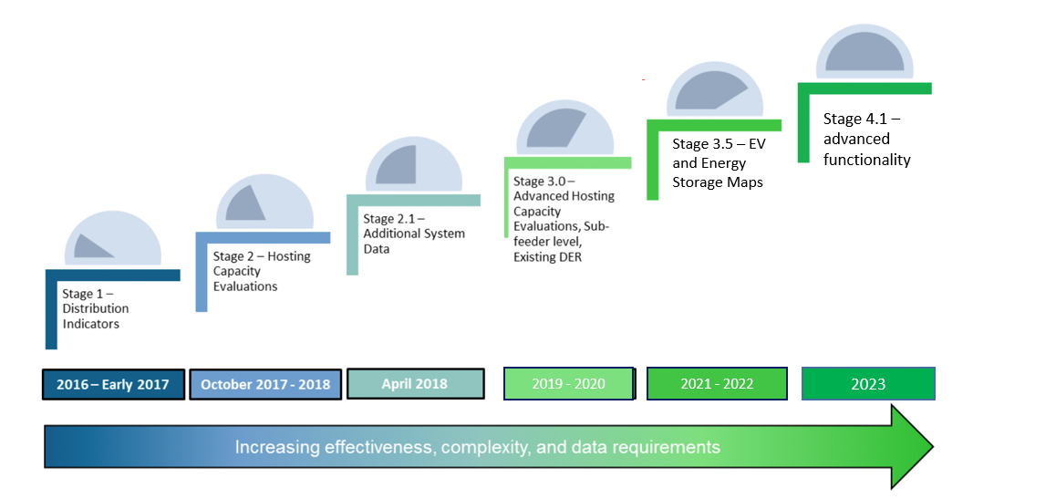

The Joint Utilities remain committed to advancing the HC Roadmap, implementing innovative solutions, and collaborating with stakeholders to maximize the value of the hosting capacity maps. In the past year, the Joint Utilities’ collective efforts have progressed through Stage 3.5 and 4.1 of the HC roadmap, detailed below.

Stage 3.5
In 2022, the JU published Storage (ESS) HC maps including:

- Feeder-level HC (min/max)
- Downloadable Feeder-level summary data
- Existing DER in circuit load curves and allocations
- sub-transmission circuits that are available to host distributed generation to help developers best evaluate options for storage connections
Stage 4.1 Overview
Based upon stakeholder feedback, in 2023, the JU published HC updates including:

- Sub-feeder level data for storage HC map
- DG connected since last HC analysis refresh
- Nodal constraints (criteria violations on PV and storage maps)
- Cost Share 2.0 items in tabular or geographic format on PV and Storage maps (shown on page 5)
- Six-month update for circuits that increase in DG > 500kW on the PV maps
- Links and/or instructions to access 8760 data
- Storage HC data made available via the API
Further information on Stage 4.1
This section provides additional information on the updates released as part of stage 4.1 of the HC roadmap, summarized above.

- The utilities published DG installed since last HCA refresh date and the refresh date so that users can have a more complete idea of HC at any given time. This data field is updated monthly.
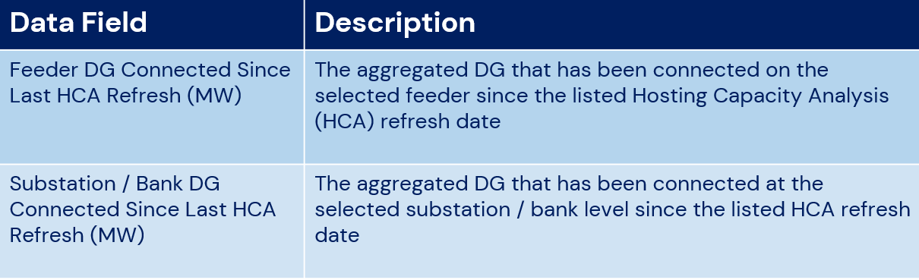

- Nodal constraints published are as follows.
  - Base Voltage (kV). The voltage of the line segment in kilovolts
  - Primary ID. The unique identifier for that line segment
  - Primary Hosting Capacity (MW). The Hosting Capacity of the selected line segment (minimum of all criteria violations below)
  - Primary Overvoltage (MW). The amount of generation that can be interconnected before the overvoltage limit is reached.
  - Primary Voltage Deviation (MW). The amount of generation that can be interconnected without causing excessive operation of voltage regulation equipment.
  - Primary Voltage Regulator Deviation (MW). The amount of generation that can be interconnected before voltage regulation equipment can wear out due to excessive operation.
  - Thermal from Generation (MW). The amount of generation that can be interconnected before thermal violations occur on the feeder
  - Anti-Islanding (MW). The amount of generation that can be interconnected before islanding is a concern for operations safety.
  - Flicker Value (MW). The amount of generation that can be interconnected before flicker can cause adverse impacts on a feeder.
  - Feeder Rating (MW). The thermal rating of the feeder.
  - Substation/Bank Rating (MVA). The amount of generation that can be interconnected on the feeder’s substation due to thermal ratings.

- Additional drawdown items associated with the Cost Share 2.0 Order are as follows.
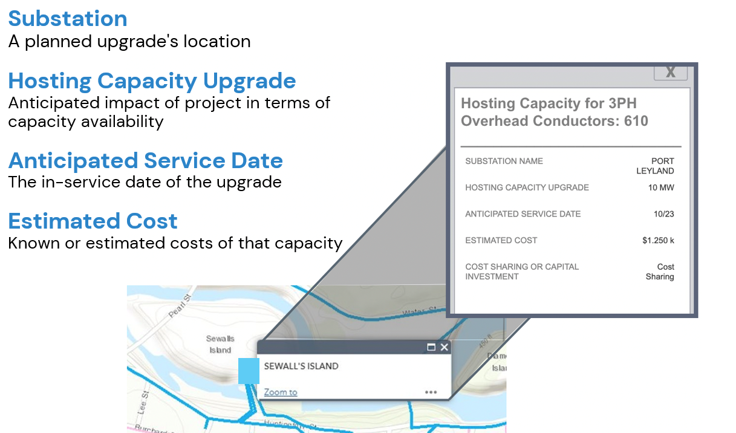

Productive Stakeholder Session
The Joint Utilities of New York have collaborated with stakeholders for the past six years to determine which hosting capacity features will provide most value to stakeholders. Most recently, the Joint Utilities held a stakeholder meeting in May 2023 to provide an overview of new features released as part of stage 4.1 of the HC roadmap, and to align on next steps.

Next Steps
The JU invites stakeholders to collaborate with the Interconnection Technical Working Group (ITWG). To maximize the value of the HC portal, the data shared on the portal should have some linkage to the Coordinated Electric System Interconnection Review (CESIR) & Standardized Interconnection Requirements (SIR). Investment in the HC maps should provide that the maps are sharing information developers can use.

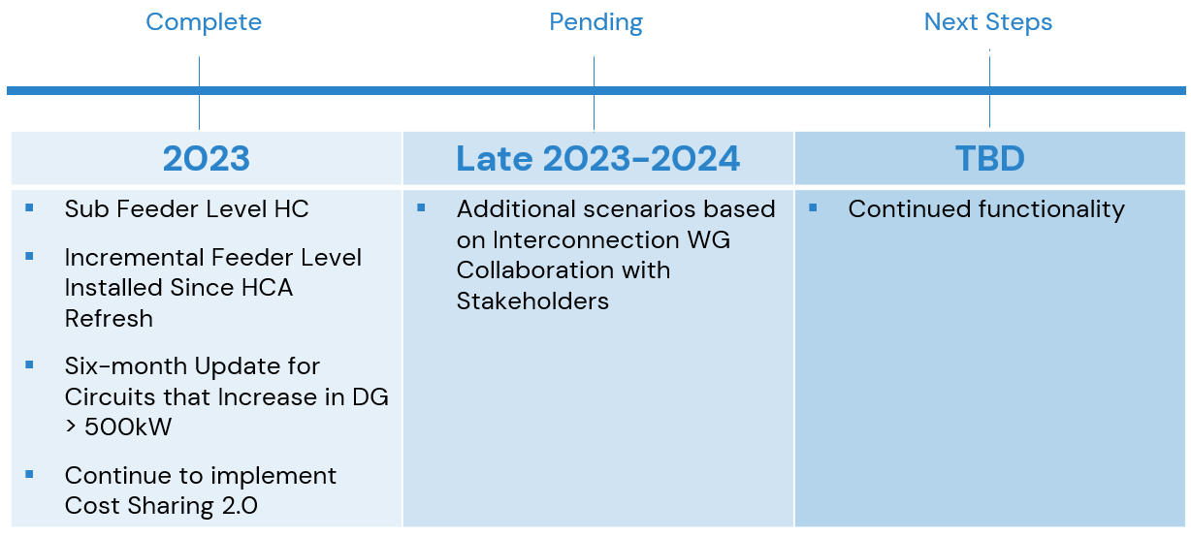

Look Ahead
In the coming year, stakeholders can expect to see the following.
- Continued work with ITWG: Once the ITWG aligns on use cases, the Integrated Planning WG will take this information to discuss next steps for advancing ESS HC maps.
- A refresh of the PV HC Map in October 2023.
- A stakeholder meeting to be held in fall 2023, to further discuss next steps and to provide functionality on the HC maps most useful to interested parties.

Information Sharing – Supporting Access to Useful Data

Integrated Energy Data Resource Platform Development
The Integrated Energy Data Resource (IEDR) is a statewide centralized platform that will facilitate users’ access to useful energy data and information to support new clean energy business models. The IEDR Program is administered by New York State Energy Research and Development Authority (NYSERDA) who guide the multi-year development of the IEDR platform. The JU Information Sharing Working Group (ISWG) is working collaboratively with the IEDR Program Development Team to advance high priority Use Cases which will drive and determine the IEDR functionality and the data and information that the JU will be providing to the IEDR to support these Use Cases.

IEDR Platform Milestones
The ISWG has been collaborating with IEDR Development Team to deliver two Phase 1 IEDR Platform development milestones:
- IEDR Initial Public Version (IPV) is the first release of the platform which went live in March 2023 and supports 3 Use Cases with downloadable data and information about installed DERs, planned DERs, and some information from the utilities’ hosting capacity maps described in the previous section, as well as other information and tools useful for planning and siting new DERs.
- IEDR Minimum Viable Product (MVP) release is planned for Q4, 2023 and will support 5 additional Use Cases, focusing on DER siting, enhanced hosting capacity/DER maps, customer energy usage data, customer billing data, and rates and tariff data.

The ISWG has been working closely with the IEDR Development Team to identify specific data and information needed to support the MVP Use Cases and have been creating and refining detailed data specifications that will assure the efficient, effective and secure transmittal of needed data from the utilities to the IEDR.

Facilitating Data Transmittal and Sharing with the IEDR Platform
The data and information needed to support the MVP Use Cases is customer or utility confidential and/or sensitive information, requiring development and execution of comprehensive legal agreements between the IEDR Development Team and the individual utilities providing the data. The JU has been working closely with the IEDR Development Team to develop an initial agreement that will facilitate sharing of some data and systems information to advance the MVP, which should be executed soon.
While this initial agreement will facilitate continued technical development of the MVP functionality, the JU filed a petition with the Public Service Commission (PSC) in December 2022 seeking clarification regarding the direct sharing of protected customer data with the IEDR Platform administrator. The requested clarification and direction from the PSC will then facilitate the needed development and execution of final data sharing legal agreements between the Joint Utilities and the IEDR Development Team to establish the appropriate data collection and transfer mechanisms to fully enable the IEDR MVP.

Status Reporting and IEDR Phase 2 Budgets
Each of the utilities filed its IEDR Q1 2023 report on April 30, 2023. These IEDR quarterly reports provide a status of the ongoing and planned projects and investments in support of the enablement of the IEDR, focusing on 1Q 2023 activities. These filings can be found under Case-20-M-0082 Proceeding on Motion of the Public Service Commission Regarding Strategic Use of Energy Related Data.

Each of the utilities filed an IEDR Phase 2 Budget Estimate on May 12, 2023. These Phase 2 Budget estimates provide details regarding the potential costs to be incurred to complete the implementation of Phase 2. The JU is currently responding to additional clarifying questions from DPS Staff and its consultant (Pecan Street) regarding the IEDR Phase 2 Budget estimates. These filings can be found under Case-20-M-0082 Proceeding on Motion of the Public Service Commission Regarding Strategic Use of Energy Related Data.

Joint Utilities Continue Working Towards a Competitive, Distributed Energy Marketplace
The Joint Utilities continue to work in support of a future energy marketplace where competitive market signals play a greater role and provide opportunity for DER. Recent utility efforts in this regard include supporting the New York Independent System Operator (NYISO)’s implementation of its new market for the participation of DER and Aggregations. Per its June 1, 2023 filing with the Federal Energy Regulatory Commission, the NYISO is expected to launch this new marketplace between Q3-Q4 of this year. The Joint Utilities have continued to work closely with the NYISO and its stakeholders to refine the workflows and information exchanges necessary for the utility review of DER and aggregations enrolling, participating, and operating in the wholesale market. Most recently, this has included refining the process for Aggregator submittal of day ahead operating schedules for DER interconnected with the distribution system. The JU discussed these requirements with prospective market participants at the NYISO’s May 23, 2023 Installed Capacity (“ICAP”) Working Group meeting. Additionally, the JU have worked closely with the NYISO to include information on this and other relevant utility processes and requirements in the NYISO’s forthcoming Aggregation Manual, which is expected to enter the NYISO’s stakeholder approval process in July.

Joint Utilities Take Steps to Facilitate Storage Interconnections
The JU are working collaboratively with developers to explore options for facilitating diverse use cases and applications for battery energy storage systems (BESS) assets and to increase their penetration on the distribution system. The JU’s work with developers includes discussions on the provision of hourly load data so that BESS can be sized appropriately, providing information on operational restrictions for specific feeders and substations, provisions associated with the shifting of operating windows and use cases, and potential ways to align BESS operating windows with time periods that could provide developers and their storage assets with the most economic value. The JU are also exploring the feasibility of providing location/ circuit – specific schedules and considerations for studying the unrestricted charge and discharge behavior of BESS assets. The JU and developers are also in the very initial stages of exploring a phased approach to enabling progressively more complex operational controls and technology to orchestrate storage assets, including the future role of DERMS and active communications to more dynamically control BESS and adjust operating windows as required.

Joint Utilities Provide Guidance on Bi-Directional EV Chargers and Mixed Use of UL 1741 – SA and SB Certified Inverters at a Site
Following discussions with members of industry, the Joint Utilities are waiving the requirement for bi-directional EV chargers to be UL 1741-SB certified, until July 1, 2024. The JU understand that there are few commercially available chargers that would satisfy the SB certification requirement today. In future, the JU will require EV chargers to possess the UL 1741 certification (SA, SB, or a later version). The granted waiver is contingent on the fact that no microgrid-interface-device (MID) is required for operation of the charger. If the bi-directional EV charger requires a MID, then no waiver will be granted, and further review of charger type testing/interoperability will be required before the system is allowed to interconnect and intentionally island.

Additionally, the Joint Utilities understand that SB – certified inverters are proliferating in greater numbers. There is a possibility that some DG sites may have a mix of SA and SB – certified inverters (mainly as existing SA inverters are replaced due to failures, performance issues etc.). The JU are of the opinion that maintenance activities that require replacement of a SA-qualified inverter with a SB-qualified inverter, if nameplate capacities of both inverters are equivalent (within the material modification guidance), the interconnection of the replacement inverter will be permitted provided that the default registers within the SB inverter can be made equivalent to the existing SA settings at the site. For activities that change the overall site power and demand levels, within context of material modification guidance, new generation or demand with the new asset(s) will require further study before interconnection approval is granted.

Paving the Way for New and Expanded Electric Vehicle Programs
New Proceeding for Medium- and Heavy-Duty Vehicle Electrification
On April 20, the Commission released an Order instituting a new proceeding to address barriers to Medium- and Heavy-Duty Vehicles. Stakeholders, including the Joint Utilities, filed initial comments in response to the Order by June 5, and reply comments by June 26.

Submetering Accuracy Technical Standards Working Group
As part of the Residential Managed Charging Order, the Joint Utilities are participating in a Technical Standards Working Group (TSWG) to investigate the accuracy of EV telematics and EV chargers for use as alternative submeters for EV load. DPS Staff have hosted biweekly TSWG webinars, which have included a robust range of presentations by industry experts including Alliance for Automotive Innovation, Ford, ChargePoint, Rolling Energy Resources, Argonne National Laboratory, ev.energy, WeaveGrid, Livingston Energy, General Motors, Tesco, EPA, and with active participation from many other groups. The Joint Utilities and Staff released a Request for Information (RFI) to gather input on this topic on May 15. The TSWG participants are currently reviewing responses, which were due on June 12.

EV Make-Ready Program – Midpoint Review
As part of the Midpoint Review of the EV Make-Ready Program, the Joint Utilities submitted initial comments on the Staff Whitepaper on May 15, followed by reply comments in response to other stakeholders on May 30. Staff held a technical conference on Data Reporting on June 12. The Joint Utilities and their subcontractor, Atlas Public Policy, each presented on the challenges of collecting the required network and participant data and suggested potential changes to the data requirements to alleviate barriers. Staff facilitated a Q&A to gather feedback on the challenges with collecting the required data, opportunities to use it, and opportunities to leverage data requirements that overlap with the requirements of the NEVI program. Staff’s presentation slides can be found here and the Joint Utilities’ slides can be found here. Additionally, the Joint Utilities have updated their Disadvantaged Communities buffer zone maps to reflect the recently adopted New York State Disadvantaged Communities definition. The updated maps can still be found via the utility websites linked below.

EV Rate Design Immediate Solutions Filings

In accordance with the Proceeding to Establish Alternatives to Traditional Demand-Based Rate Structures for Commercial Electric Vehicle Charging (EV Rate Design), the utilities filed their Immediate Solutions 60-day filing on March 20, which included plans for the implementation of Upstate and Downstate Demand Charge Rebates, a Downstate Commercial Managed Charging Program, the termination of Con Edison’s EV Business Incentive Rate, and the termination of the statewide Per-Plug Incentive. The utilities will also file their implementation plans for the Phase-in Rate and the Upstate Commercial Managed Charging Program by July 18. All filings related to this proceeding can be found under Case 22-E-0236.

Tools and Informational Sources
Advanced Forecast | Joint Utilities  Joint Utilities: Overview of Currently Accessible System Data  Joint Utilities: Load Forecasts  Joint Utilities: Historical Load Data
Beneficial Locations | Joint Utilities  Joint Utilities: Beneficial Locations
Customer Data | Central Hudson  Central Hudson: Privacy Policy | Con Edison  Con Edison: Customer Energy Data | National Grid  National Grid: NY System Data Portal | NYSEG RG&E  NYSEG: Your Energy Data | O&R  O&R Information on Requesting Aggregate Whole Building Data  O&R Energy Service Company EDI  O&R New York Rates and Tariffs  O&R Share My Data
DER Integration & Inter-connection | Joint Utilities  Joint Utilities: Distributed Generation  Joint Utilities: Interconnection  Joint Utilities: SIR Pre-Application Information
 | Central Hudson  Central Hudson: Distributed Generation Homepage  Central Hudson: Interconnection Queue | Con Edison  Con Edison: Private Generation Energy Sources | National Grid  National Grid: Systems Data Portal  National Grid: Interconnection | NYSEG RG&E  A Developer’s Guide to the NYSEG/RG&E Interconnection On-line Application Portal  NYSEG - Online Portal  RG&E - Online Portal  NYSEG - Queue  RG&E – Queue  SIR Inventory requests: NYRegAdmin@avangrid.com | O&R  O&R: Distributed System Platform  O&R Private Generation Energy Sources
Energy Efficiency | Central Hudson  Central Hudson: Energy Efficiency | Con Edison  Con Edison: Energy Star | National Grid  National Grid: Energy Savings Programs | NYSEG RG&E  NYSEG: Smart Energy  RG&E: Energy Efficiency Incentives | O&R  O&R: Energy Efficiency Rebates
Energy Storage | Central Hudson  Central Hudson: Projects | Con Edison  Con Edison: Energy Storage | National Grid  National Grid: Battery Programs | NYSEG RG&E  NYSEG RG&E: Energy Storage Service Agreement | O&R  O&R Private Generation Tariffs
EV Integration | Joint Utilities  Joint Utilities: EV Programs  Joint Utilities: Approved Contractor List with New Filter Capabilities
 | Central Hudson  Central Hudson: EV Homepage | Con Edison  Con Edison: Electric Vehicles | National Grid  National Grid: Upstate NY Electric Vehicles Hub | NYSEG RG&E  NYSEG: Electric Vehicles  RG&E: Electric Vehicles | O&R  O&R Electric Vehicles Information  O&R Electric Vehicle Guest Drive Event Video
Hosting Capacity | Joint Utilities  JU Utility Specific Hosting Capacity
 | Central Hudson  Central Hudson: Hosting Capacity Maps | Con Edison  Con Edison: Hosting Capacity | National Grid  National Grid: ESRI Portal | NYSEG RG&E  NYSEG/RGE Hosting Capacity Map | O&R  O&R Hosting Capacity and System Data
NWAs | Joint Utilities  Joint Utilities: Utility-Specific NWA Opportunities
 | Central Hudson  Central Hudson: NWAs | Con Edison  Con Edison: Non-Wires Solutions | National Grid  National Grid: NWA | NYSEG RG&E  NYSEG - Non-Wires Alternatives  RG&E - Non-Wires Alternatives | O&R  O&R NWA Opportunities  Non-Wires Alternatives Opportunities Portal
Progressing the DSP | Joint Utilities  Joint Utilities: Utility DSIPs  Joint Utilities: Capital Investment Plans  Joint Utilities: Electric Reliability Reports

