p
JOINT UTILITIES OF NEW YORK

DISTRIBUTED SYSTEM PLATFORM (DSP) ENABLEMENT QUARTERLY NEWSLETTER

WHAT’S INSIDE
JU Prepare for the Launch of NYISO’s DER Market
…………………………………………………………………………………………………………….… 1-2

Information Sharing – Supporting Access to Useful Data
…………………………………………………………………………………………………………….… 2-3

Join Us at the Next HC Map Stakeholder Session!
…………………………………………………………………………………………………………….… 3-5

Joint Utilities Continue Work on Facilitating Storage Interconnections and Exploring Use of EPRI’s Common File Format for Inverter Settings
…………………………………………………………………………………………………………….… 6-7

New Opportunities for New York’s EV Drivers
…………………………………………………………………………………………………………….… 7

Tools and Informational Sources
…………………………………………………………………………………………………………….… 8-10

JU Prepare for the Launch of NYISO’s DER Market
FERC Order No. 2022 (FERC 2222) and the NYISO’s compliance filing and tariff changes enable distributed energy resource (DER) aggregations to participate in the wholesale electricity markets. Several DERs can be aggregated to satisfy minimum size and/or performance requirements that resources may not meet individually. NYISO’s tariff changes will enable benefits including lower costs for consumers through enhanced competition, more grid flexibility and resilience, and increased innovation within the electric power industry.

The Joint Utilities continue to make progress on readiness activities pertaining to the NYISO DER Market Participation Model Launch (DER market launch), for which enrollment is scheduled to begin in the fall of 2023. The Joint Utilities continue to join bi-weekly workshops with the NYISO and the State Commission Staff to advance market readiness by resolving topics pertaining to DER participation. Most recently, the Joint Utilities have collaborated on the following items:

- Billing and crediting workflows and the associated tariff change process
- Registration and enrollment processes
- Settlement issues
- Meter change-out workflows, requirements, and process
- Changes to NYISO manuals
The Joint Utilities also recently held a detailed discussion on the topic of enrollment, billing, and crediting processes, wherein the companies walked through each of these processes within the context of a hypothetical DER aggregator participating in NYISO. The Joint Utilities are following up with NYISO to answer some specific clarifying questions that arose during this session. The companies will also soon be facilitating a similar detailed conversation on the topic of settlements, to illustrate the nuances of the settlement process with DER aggregators.

Separately, the Joint Utilities are implementing processes and procedures that will support the DER market launch and transition participating customers to appropriate requirements such as metering and tariffs, as well as DER Aggregator information pages or portals.

Additionally, the Joint Utilities continue to participate in and support NYISO working groups, such as the MIWG and ICAPWG, as needed.

Information Sharing – Supporting Access to Useful Data
Integrated Energy Data Resource Platform Development
The Integrated Energy Data Resource (IEDR) is a centralized state-wide platform that provides access to useful energy data and information from New York's electric, gas, and steam utilities, and other sources, to support new and innovative clean energy business models and benefit New York energy customers.

This quarter, the JU Information Sharing Working Group (ISWG) continued work alongside system developers and the IEDR Program Development Team to advance prioritized stakeholder use cases that provide the greatest value to New York residents. The JU is working with regulators to establish safe and secure data exchanges that enable use cases. While a number of policy issues remain to be resolved, the JU was able to negotiate a limited data sharing agreement to continue working on system development while assuring appropriate level of data privacy protection, helping to minimize any delays in developing the IEDR system.

On October 13, the PSC issued an Order in Case-20-M-0082 Proceeding on Motion of the Public Service Commission Regarding Strategic Use of Energy Related Data. The Order responded to the JU Petition for clarification from December 1, 2022 seeking commission direction regarding the direct sharing of protected customer data with the IEDR platform administrator. The Order requires that utilities should be in position to begin data transfer by 60 days after the Order. The JU continues to prepare necessary legal agreements, such as updated tariffs and data sharing agreements, to protect customer privacy and mitigate cybersecurity risks. The JU is also working to update important tariff language and legal agreements under the clarified rules and ensuring important IEDR system development and testing occur.

The JU continues to support IEDR movement toward Phase 1 milestones while preparing for Phase 2 which will begin in 2024. Phase 2 plans and individual utility budget projections can be found in Case-20-M-0082. As described in our July Newsletter, the IEDR Initial Public Version (IPV) went live in March 2023 and supports 3 use cases including information for Large Installed DERs, Large Planned DERs, and a consolidated state-wide Hosting Capacity map. The IEDR supports data downloads and includes tools for planning and siting new DERs.

Join Us at the Next HC Map Stakeholder Session!
Overview
Hosting capacity (HC) is defined as the estimated capacity of distributed energy resources (DER) that can be integrated into the existing infrastructure without compromising power quality or reliability, and without the need for infrastructure upgrades. With stakeholder feedback, the Joint Utilities (JU) continue to update the Photovoltaic (PV) HC Maps and Storage (ESS) HC Maps, making significant advancements in the overall HC Roadmap below, which outlines the strategic approach to managing map development.

The next stakeholder session will be hosted by the Integrated Planning Working Group and held on November 2, 2023, from 12:00-1:30pm ET. You can access the login information on the JU Stakeholder calendar here.

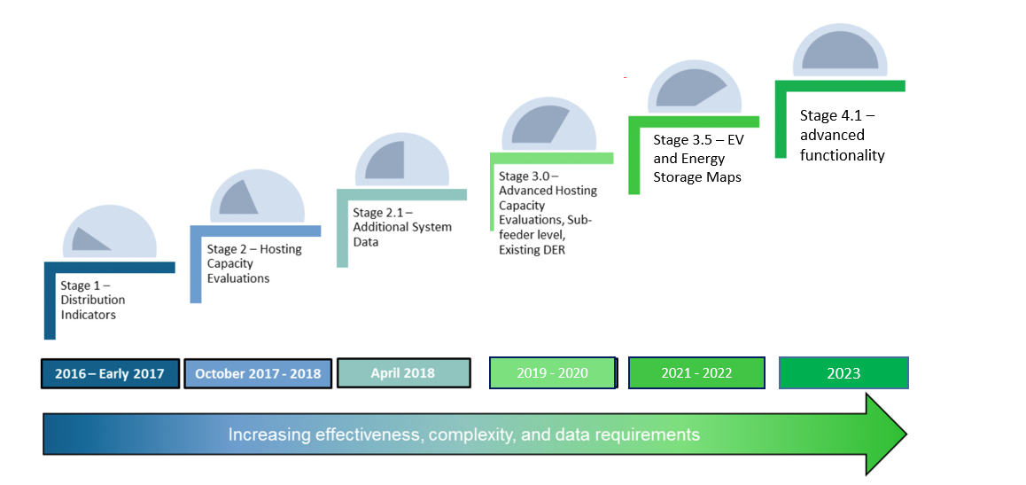
The JU are dedicated to advancing the HC Roadmap, working closely with stakeholders to add functionality to the HC maps. A brief history of HC advancements is as follows.

2016-2018 | The JU releases early indicator maps for PV HC in 2017 utilizing the EPRI drive tool. In 2018, the JU publishes circuit level HC maps for PV.
2019 | The JU publishes sub-circuit level hosting capacity maps for PV and expands the yearly update to include an added 6-month update for circuits that experienced >500 kW increase in DG since the last yearly update.
2020-2021 | The JU provides circuit level EV maps in response to stakeholder feedback.
2022 | JU releases the ESS HC Maps in response to stakeholder feedback.
2023 | The JU adds functionality to the HC Maps including adding sub-feeder level data to the ESS HC Maps as explained in more detail below. The Integrated Planning Working Group initiates collaboration with the Interconnection Technical Working Group (ITWG) to provide additional load scenarios in the future for the ESS maps.

Further Progress in 2023
In the past year, the JU has progressed through Stage 4.1 of the HC Roadmap, providing continued functionality to the ESS HC Maps as detailed below. The JU also announced plans to publish additional features on the PV and ESS HC maps. Additionally, the JU and DPS Staff are discussing the publication of an electrification map.

Stage 4.1 Overview: Advanced Functionality
Based upon stakeholder feedback, in 2023, the JU published HC updates including:

- Sub-feeder level data for storage HC map
- DG connected since last HC analysis refresh
- Nodal constraints (criteria violations on PV and storage maps)
- Cost Share 2.0 items in tabular or geographic format on PV and Storage maps
- Links and/or instructions to access 8760 data
- Storage HC data made available via the API
Coming Soon: T-Nodes
The JU are adding T-nodes to the PV and Storage HC maps to support the needs of NYISO market aggregators. Utilities hope to make this update by year end. The T-nodes will show as a data field in the draw-down as shown below.

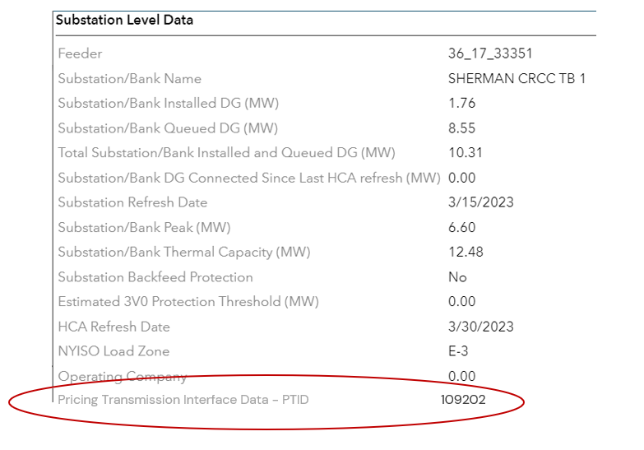
T-Node

Updating the PV and ESS HC Map Refresh Cycle
Every year the JU refresh the PV HC Maps in October and the Storage HC maps in April. Starting in 2024, on an annual basis, the JU will refresh both the PV and Storage HC Maps in the spring to enable resource alignment.

Next Steps for the ESS HC Maps
To maximize the value of the HC portal, the data should reflect the CESIR process. The Integrated Planning Working Group requested the Interconnection Technical Working Group (ITWG) discuss and align upon use-cases with developers with the goal of adding functionality to the HC maps in alignment with ITWG.

At the last ITWG meeting with industry stakeholders and Staff on 9/21, each of the JU presented their preliminary energy storage schedules. The JU has yet to receive feedback from industry stakeholders. DPS Staff is working to set up meetings between the JU and industry stakeholders to further discuss the ESS schedules.

In Discussion: Electrification Maps
Two orders are directing the expansion of the EV Load Capacity Maps to include heating electrification: the Electric Vehicle Process Mid-Point Review and the Energy Efficiency and Building Electrification Order issued and effective on July 20, 2023. In compliance with these orders, the JU is in communication with DPS Staff to update the EV maps to include functionality aligned with greater electrification use-cases.

Stakeholder Participation Requested!
Stakeholder feedback is integral to progressing the HC maps. The JU seeks to continue providing additional functionality and value in alignment with stakeholder needs. To this end, the JU has scheduled a HC Maps Stakeholder session on November 2, 2023, from 12:00pm – 1:30 pm ET. At this stakeholder session, the JU will review progress and updates, discuss next steps for the HC Maps, and seek stakeholder feedback. Log-in information for the stakeholder session can be found here.

Joint Utilities Continue Work on Facilitating Storage Interconnections and Exploring Use of EPRI’s Common File Format for Inverter Settings
The JU continue to work collaboratively with developers to explore options for facilitating diverse use cases and applications for battery energy storage systems (BESS) assets and to increase their penetration on the distribution system. The JU’s work with developers includes discussions on the provision of hourly load data so that BESS can be sized appropriately, providing information on operational restrictions for specific feeders and substations, provisions associated with the shifting of operating windows and use cases, and potential ways to align BESS operating windows with time periods that provide developers and their storage assets with the most economic value.

Accordingly, each JU member has created and supplied territory – wide charge and discharge BESS schedules to developers. The JU created these schedules after examining the operational characteristics of existing BESS assets and load patterns on their distribution systems. These schedules are intended to help developers fulfill multiple use cases, including participation in the NYISO markets, as well as being able to maximize revenue accrued through the value of DER (VDER) mechanism. The JU may adjust these schedules on a case-by-case basis during the interconnection study stage to ensure system safety and reliability, while seeking to fulfill developer needs, and may modify these schedules in future as BESS penetration rises and system conditions change. The JU are holding a discussion with DPS Staff and developers in the near future to discuss these schedules and address any questions that developers might have.

Additionally, earlier this year, each of the companies provided files information on inverter settings to DPS Staff and developers. These files conformed to a common file format for settings developed by EPRI. The JU prepared separate files with settings for DERs sized above and below 50 kW. By creating and making available such company – specific settings files to inverter manufacturers, inverters shipped to a project site within a particular utility’s service territory can be preconfigured with that company’s default setpoints, improving the efficiency of the DER interconnection process. As a next step, the JU are following up with inverter manufacturers and vendors to understand when manufacturers will be ready to accept and input the utility – developed settings files into their inverters.

New Opportunities for New York’s EV Drivers
Managed Charging Program Implementation
The utilities have begun implementing residential managed charging programs per DPS Staff’s July 2022 Order Approving Managed Charging Programs with Modifications. Utility customers participating in the programs will be able to earn off-bill incentives for EV charging during off-peak hours. The programs help reduce stress on the grid making it more resilient and reliable, while also allowing participating customers to save money.

Make-Ready Program Midpoint Review Continues
The Joint Utilities continue to coordinate with DPS Staff and stakeholders to provide information that will influence the adjustments made for the second half of the EV Make-Ready Program. Staff held a Technical Conference on Program Budget and Program Targets on July 27 in person and via WebEx, where the Joint Utilities provided feedback and proposed adjustments to the plug targets for the remainder of the program. Additionally, Staff held a Workforce Development webinar on September 7, to share information about workforce development programs from New York State Energy Research and Development Authority (NYSERDA). The webinar also included presentations by Livingston Energy Group and ChargerHelp! The recording is available on the DPS website. Staff is expected to release a Midpoint Review Order this fall. Materials pertaining to the EV Make-Ready Program, including stakeholder comments and technical conference presentations, can be found on the DPS website under Case 18-E-0138.

Tools and Informational Sources
Advanced Forecast | Joint Utilities  Joint Utilities: Overview of Currently Accessible System Data  Joint Utilities: Load Forecasts  Joint Utilities: Historical Load Data
Beneficial Locations | Joint Utilities  Joint Utilities: Beneficial Locations
Customer Data | Central Hudson  Central Hudson: Privacy Policy | Con Edison  Con Edison: Customer Energy Data | National Grid  National Grid: NY System Data Portal | NYSEG RG&E  NYSEG: Your Energy Data | O&R  O&R Information on Requesting Aggregate Whole Building Data  O&R Energy Service Company EDI  O&R New York Rates and Tariffs  O&R Share My Data
DER Integration & Inter-connection | Joint Utilities  Joint Utilities: Distributed Generation  Joint Utilities: Interconnection  Joint Utilities: SIR Pre-Application Information
 | Central Hudson  Central Hudson: Distributed Generation Homepage  Central Hudson: Interconnection Queue | Con Edison  Con Edison: Private Generation Energy Sources | National Grid  National Grid: Systems Data Portal  National Grid: Interconnection | NYSEG RG&E  A Developer’s Guide to the NYSEG/RG&E Interconnection On-line Application Portal  NYSEG - Online Portal  RG&E - Online Portal  NYSEG - Queue  RG&E – Queue  SIR Inventory requests: NYRegAdmin@avangrid.com | O&R  O&R: Distributed System Platform  O&R Private Generation Energy Sources
Energy Efficiency | Central Hudson  Central Hudson: Energy Efficiency | Con Edison  Con Edison: Energy Star | National Grid  National Grid: Energy Savings Programs | NYSEG RG&E  NYSEG: Smart Energy  RG&E: Energy Efficiency Incentives | O&R  O&R: Energy Efficiency Rebates
Energy Storage | Central Hudson  Central Hudson: Projects | Con Edison  Con Edison: Energy Storage | National Grid  National Grid: Battery Programs | NYSEG RG&E  NYSEG RG&E: Energy Storage Service Agreement | O&R  O&R Private Generation Tariffs
EV Integration | Joint Utilities  Joint Utilities: EV Programs  Joint Utilities: Approved Contractor List with New Filter Capabilities
 | Central Hudson  Central Hudson: EV Homepage | Con Edison  Con Edison: Electric Vehicles | National Grid  National Grid: Upstate NY Electric Vehicles Hub | NYSEG RG&E  NYSEG: Electric Vehicles  RG&E: Electric Vehicles | O&R  O&R Electric Vehicles Information  O&R Electric Vehicle Guest Drive Event Video
Hosting Capacity | Joint Utilities  JU Utility Specific Hosting Capacity
 | Central Hudson  Central Hudson: Hosting Capacity Maps | Con Edison  Con Edison: Hosting Capacity | National Grid  National Grid: ESRI Portal | NYSEG RG&E  NYSEG/RGE Hosting Capacity Map | O&R  O&R Hosting Capacity and System Data
NWAs | Joint Utilities  Joint Utilities: Utility-Specific NWA Opportunities
 | Central Hudson  Central Hudson: NWAs | Con Edison  Con Edison: Non-Wires Solutions | National Grid  National Grid: NWA | NYSEG RG&E  NYSEG - Non-Wires Alternatives  RG&E - Non-Wires Alternatives | O&R  O&R NWA Opportunities  Non-Wires Alternatives Opportunities Portal
Progressing the DSP | Joint Utilities  Joint Utilities: Utility DSIPs  Joint Utilities: Capital Investment Plans  Joint Utilities: Electric Reliability Reports

